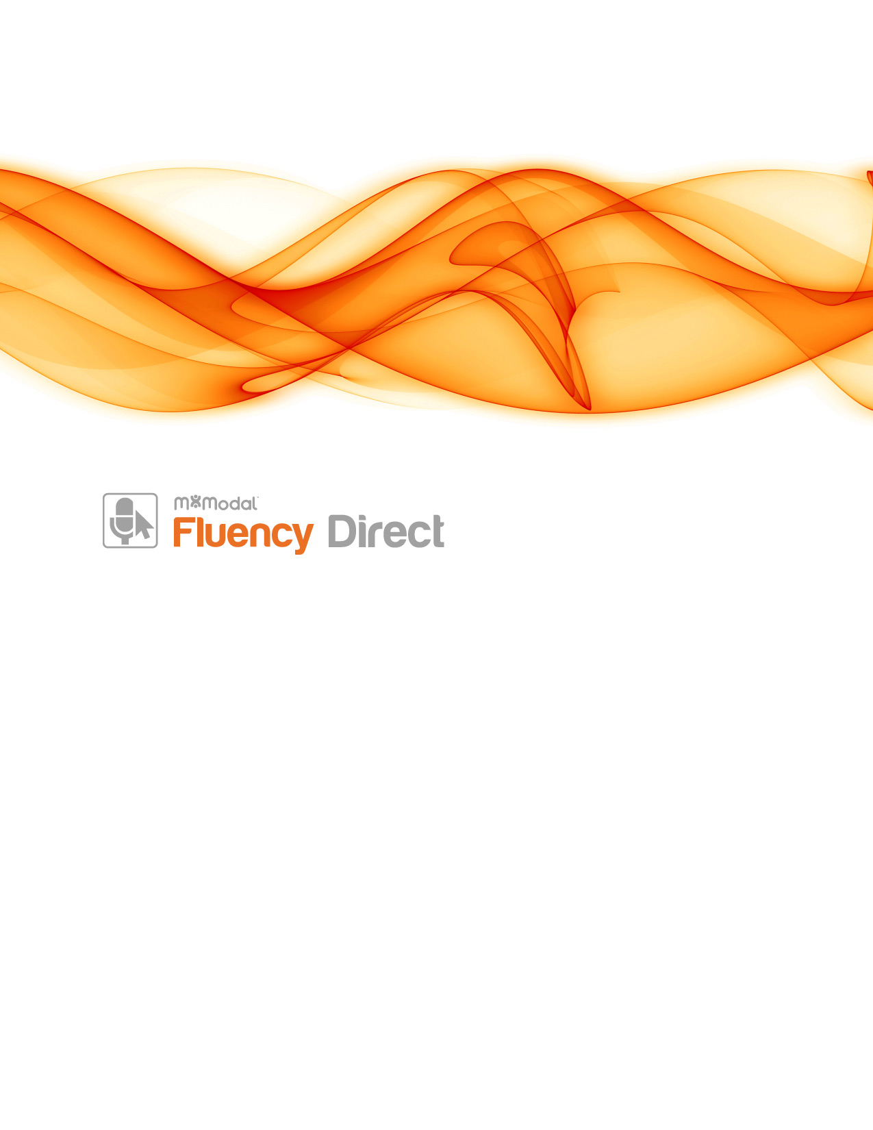

Transition to 10.0

7.85 to 10.0

Confidentiality Disclaimer
All information methods and concepts contained in or disclosed by this document is confidential and proprietary to MModal Services Ltd. By accepting this material, the recipient agrees that this material as well as the information and concepts contained therein will be held in confidence and will not be reproduced in whole or in part without express written permission from MModal Services, Ltd. Client use of M*Modal tools or information (excluding any services or tools provided to the Client that are covered under a separate written agreement) is subject to the terms of a legal agreement between the Client and M*Modal.

Contact Information
Corporate Address | M*Modal Corporate  5000 Meridian Blvd, Suite 200  Franklin, TN 37067
Support Hotline (24/7) | (800) 290 - 2001
Support Email | Fluency.Direct@mmodal.com
Sales | (866) 542 - 7253

Table of Contents
Overview 6
Upgrade Best Practices 7
Preparation for the Upgrade 7
Steps to Upgrade 7
Requirement Changes 9
Performance Enhancements 10
Recognizer Improvements 10
Better EHR Integration 11
Expanded Web Browser Support 11
Expanded Text Control Support 11
Control Bar and Window Layout Memory 11
Fluency Direct Connector 11
Configuration Files 12
Connector for Citrix XenApp and Terminal Services 12
Connector as a Windows Service 12
Visual Feedback on Connectivity 12
Single-Signon Support 13
Explicit Account Name for SSOUser 13
LDAP Support 13
Installer 14
Customization 14
Self-Heal 14
Conflicts with running applications 14
Feature Enhancements 15
User Interface Changes 15
Online Documentation Portal 15
Mobile Microphone 16
Unlinking Mobile Microphone 16
Correction Dialog 17
Visual Pronunciation and Pronunciation Options 17
Spelling 18
M*Modal Exchange 18
Import/Export 18
Dictionary 19
Pronunciation Review/ Hidden Words 19
Term Suggestions 19
Abbreviations 20
Import/Export 20
Hidden Mode 20
Commands 20
Import/Export 20
Availability 21
Expanded Command Actions 21
Mouse 22
Commands 22
Window 22
Wait 23
Comment 23
Grammar IDE 23
Data Sets for Grammars 23
Data Sets – Import/Export 24
Scripting IDE 24
Formatting 24
Explicit capitalization and numbers 24
Medical Specialty 25
Device Button Mapping 25
Mobile Microphone App 26
Nuance Power Mic I and Power Mic II 26
Better Microphone, Foot Pedal and Hand Control Support 26
Recording Mode 26
Import/Export 26
Speech Box 27
Account Settings for Self Service Password Resets 27
Password Self Reset 27
Troubleshooting 28
System Check 28
Microphone Testing tools 28
Activity Log 28
Published Items 28
CAPD 29
General Fixes in CAPD version > 7.11.11 29
Actionable Messages 29
Support for HCCs 29
Release Notes 30

Overview
At M*Modal, we want our customers to have our latest and greatest software. We are keenly aware that upgrading software can be time consuming and resource intensive. Because of that, we deliver recognition enhancements and continuously-learning voice profiles via M*Modal’s Cloud intelligence model. This allows us to deliver regular improvements at no burden to our customers.

Our development team is constantly developing new software. Some of these developments include user interface changes to improve the end user’s workflow experience with Fluency Direct. Others include “under the covers” improvements to the software performance and speech algorithms.

We see our customers as partners and try to strategically recommend upgrades that are truly worth your time. Recently, we developed a new version of Fluency Direct that we are sure our customers will appreciate. We want the opportunity to wow our end users with new features and outstanding speech recognition quality.

Based off end-user feedback, M*Modal’s Fluency Direct now has several changes to better accommodate user needs and workflows. Along with feature updates, Fluency Direct has expanded support for EHRs and additional deployment methods. Below is a review of M*Modal’s upgrade best practices and the most recent changes to Fluency Direct.

Upgrade Best Practices
In an effort to deliver our customers these exciting enhancements, we decided to lay out a path to upgrading that is simple. Follow these best practices for a smooth process.

Preparation for the Upgrade

- The M*Modal Fluency Direct Documentation Portal contains up-to-date documentation for Fluency Direct. You should have access to Fluency Direct and its Web Admin Console User Guides, training materials, technical documents, and even marketing materials.
  - Follow this link for Self-Registration
  - Links throughout this document go to the Fluency Direct Documentation Portal and require login to view
- Review the REQUIREMENTS CHANGES, FEATURE ENHANCEMENTS, and the Release Notes (on the portal) to see the full list of software updates
- Review the technical documents on the portal, such as the Client Deployment Guide or Citrix XenApp Connector Setup, applicable to your current deployment
- Schedule demonstration with your Adoption Specialist (optional)

Steps to Upgrade
- Download the installer package from the mmodal.box.com link supplied via email
  - Once the download is complete, open and extract the downloaded zipped file through WinZip to your preferred local destination, such as the Desktop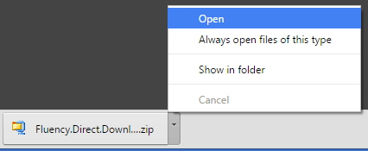
  - Launch FluencyDirectDownload.exe by right clicking on the file and choosing the Run as administrator option
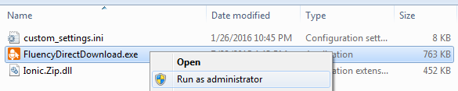
  - Click the Start Download button
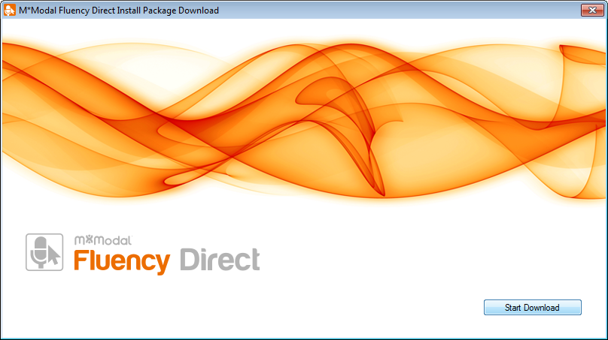
- Install and deploy Fluency Direct in recommended sequence
  - If utilizing the Connector and/or Remote Recognition servers, they should be upgraded first
    - Connector best practices: XenApp, Remote Desktop, or Parallels 2x Remote Application
    - Remote Recognition deployment overview
  - The client should follow after, however an older client can work successfully with a newer Connector and newer Remote Recognition server software through a transitional period
  - It is recommended for all components (client, remote recognition, connector, etc.) to be upgraded to the versions supplied
- Installation tips for Fluency Direct and other applicable components if virtualized
  - Client deployment
    - Review the Fluency Direct Overview and the Client Deployment Guide for detailed information and client deployment options
    - Notice new batch files if planning to deploy via SCCM or other auto-distribution
    - If the existing client is version 7.85 or higher, there is no need to uninstall prior to installing the upgrade
    - If installing the client locally, navigate to the fd.client folder, select the install.bat file, and choose Run As Administrator
  - Virtualization setup
    - Review the relevant information at the Virtualization Options page for detailed deployment overviews and setup guides
    - If the existing Connector is version 7.85 or higher, there is no need to uninstall prior to installing the upgrade
    - Consult our Decision Tree and Connector or Zero-Client Pros and Cons for best practice recommendations per environment

- Test Fluency Direct in appropriate environment(s)
  - Follow the Validation Checklist for a complete testing guide
  - Find more information about specific EHR Compatibility and expected voice command behavior

Requirement Changes
- .Net Framework 4.0 (fully patched) or higher
- Whitelist sites:
  - fluencydirect.mmodal.com:443
  - fd-phl.mmodal.com:443
  - audiorelayserver.mmodal.com:8077
  - fluencyupdate.mmodal.com:443
  - catalyst-apps.mmodal.com:443
- CPU Benchmark of 3000 or higher (www.cpubenchmark.net)
  - Processor: Intel Core 2 CPU, 1.5 ghz, 2GB minimum for Local recognition
  - Processor: Intel Core 2 CPU, 1.5 ghz, 1GB minimum for Remote recognition
- Microsoft® Internet Explorer Version 6 (SP1) or higher
- For dictation support into Java based applications JRE 1.7 u6 (32 bit) or higher needs to be installed on the computer before Fluency Direct is installed.
- For Citrix XenApp support with the Fluency Connector, you must have already installed the Citrix Client 10, 11, 12 or the Citrix Receiver in advance of installing Fluency Direct as well as have the Connector configured on the Citrix Server.

Performance Enhancements

Recognizer Improvements
The M*Modal speech engine is always being fine-tuned with minor changes pushed out via the M*Modal Cloud (data center) and with major changes that are coupled with upgrades. We have put extensive work into specialty-specific language algorithms in recent years. Our latest speech technology, bundled into the latest version of Fluency Direct, is proving to have a significant impact on user accuracy.

The subjective feedback from users about this latest update has been overwhelmingly positive with providers quickly taking notice of the recognition improvements. The objective data shows that 1/3 of users have seen over a 30% reduction in misrecognitions, while 2/3 of users have seen at least a 20% reduction. We feel strongly that our new recognition technology will have a significant impact on documentation quality and provider satisfaction when our customers move forward with this upgrade.

11-20%
>31%
Decrease in Recognition Errors
21-30%
<10%
The Measured Changes in Accuracy for 100 Providers after Upgrade

Better EHR Integration

Expanded Web Browser Support
- Firefox now has its own Fluency Direct extension. This will be installed at install time. This allows full level 3 support for all contentEditable DIVs.
- Level 3 Support has been expanded to include
- Microsoft Edge on Windows 10
- Google Chrome 32-Bit

Expanded Text Control Support
- With the addition of UI Accessibility support, Level 3 support has been extended to
  - Silverlight based applications
  - Greenway Intergy
  - Other WPF based applications (testing and configuration will apply)
- Fluency Direct now better supports e-MDS EMR with Level 3 support
- Improved Automatic Spacing Logic to allow lookup fields to work better in Meditech Client Server. Extra spaces should no longer cause filtered list problems in search fields.

Control Bar and Window Layout Memory

- Previously, Windows and control bar positioning was stored per Windows User on a given workstation. This meant that all users using the given Window account would have the same position memory. This has been expanded to allow memory across computers and for individual Fluency Direct Users (not Windows Users). Whether you would like to remember position across computers is now configurable via Settings.

- Updated control menu to a unified model to no longer required access to nested menus for common tasks.

Fluency Direct Connector
The Session Manager Service now fully supports Terminal Services and Remote Desktop Services. This service functions the same way it does in Citrix. If a running instance of Fluency Direct is detected on a workstation then the Connector will automatically run.

Configuration Files
All configuration files have been combined into a single C:\ProgramData\MModal\DesktopDictationClient\localSettings.config file. This file now contains all configuration items for

- The Fluency Direct Client behavior
- SSO
- Recognition Modes
- sFTP
- Web Proxy
- Auto-Update

You no longer require admin rights to modify.

Connector for Citrix XenApp and Terminal Services

Connector as a Windows Service
With prior versions of Fluency Direct, the Fluency Direct Connector needed to be launched alongside a published application. Fluency Direct version 9.1.101.7.8.5 and later implement auto-launching from a Windows Service. When installing the Connector, the Installer creates the “M*Modal Fluency Direct Session Manager Service” which allocates 2 MB to the server when running. This service is shared by all Citrix and Terminal Services Sessions. It is no longer necessary to define scripts, login routines or published applications to explicitly launch the Connector (FDConnect.exe) or Session Manager (FDSessionMgr.exe) process. While not recommended, if you wish to continue launching FDConnect.exe or FDSessionMgr.exe explicitly via these previous methods, you must disable the “M*Modal Fluency Direct Session Manager Service” service.

The Connector Service improves Fluency Direct in two fundamental ways.

The Service uses significantly less memory than previous configurations. In some cases as much as 90% less.
The Service no longer requires knowledge of Citrix configuration. The Service will make sure the Connector is running if Fluency Direct is running on the client workstation. In this way, the Connector is always running when it is suppose to be even if a Physician clicks on a "wrong icon".

Visual Feedback on Connectivity
The Control Bar's record button will now visually indicate success or failure with the Connector connectivity.

- Green = Connector working correctly
- Blue = Connector is not running on the Citrix XenApp or Terminal Services Server
- Orange = Install incorrect on the client. Either the Citrix Receiver or Remote Desktop Client do not have the correct virtual drivers installed as part of FD. This could happen if the Citrix Receiver isn't restarted after install or if a new install of the Citrix Receiver was done and a Fluency Direct self-heal was not possible.
- Red = Severe problem typically related to microphone or remote recognition server.

Single-Signon Support

Explicit Account Name for SSOUser
Previously Shared SSOUser Account names were calculated based on the type of SSO. That can still be true, but a new configuration item has been added to allow for the explicit naming of user accounts. This change allows for more meaningful names for User accounts, easier setup as well facilitates multiple SSO methods to share single user. If Account is not specified, the name is calculated as before.

in localsettings.config
<config key="MModalSSO.Account" value="SharedUserSSO" />
<config key="MModalSSO.AuthKey" value="lxsJHAkGrwZZ06zAVRlS0jskjCJJW3VwaBzLkP6bVS0=" />

in customsettings.ini
ClientSSOAccount="SharedUserSSO"
ClientSSOAuthKey="lxsJHAkGrwZZ06zAVRlS0jskjCJJW3VwaBzLkP6bVS0="

LDAP Support
Fluency Direct now has the ability to use Active Directory via LDAP as an authentication source. In this way, users can authenticate against AD, but access their Fluency Direct user account of the same username. For example BSMITH in AD would also need to be BSMITH for Fluency Direct.

in localSettings.config
<config key="MModalSSO.Application" value="LDAP" />
<config key="MModalSSO.Name" value="" />
<config key="MModalSSO.InitString" value="interactivesys.com" />
<config key="MModalSSO.Account" value="SharedUserSSO" />
<config key="MModalSSO.AuthKey" value="lxsJHAkGrwZZ06zAVRlS0jskjCJJW3VwaBzLkP6bVS0=" />
<config key="MModalSSO.UppercaseUsername" value="true" />

in customsettings.ini
ClientSSOName=""
ClientSSOApplication="LDAP"
ClientSSOInitString1="interactivesys.com"
ClientSSOAccount="SharedUserSSO"
ClientSSOAuthKey="lxsJHAkGrwZZ06zAVRlS0jskjCJJW3VwaBzLkP6bVS0="
DISABLEAUTOLOGIN=Y
ClientSSOUPPERCASEUSERNAME=True

Installer

Customization
The installer now has an additional ability to be customized. Four VBScripts are now run at install time and can be used to configure the environment in different ways. Including, but not limited to, setting configuration settings.

preInstallClient.vbs - Run before the Fluency Direct Client MSI is run.
postInstallClient.vbs - Run after the Fluency Direct Client MSI is run. This is a useful place to set customer specific configuration settings.
preInstallConnector.vbs - Run before the Fluency Direct Connector MSI is run.
postInstallConnector.vbs - Run after the Fluency Direct Connector MSI is run. This is a useful place to set customer specific configuration settings.

Self-Heal
The Client MSI is no longer necessary when configuring Windows User specific settings for the Client such as Citrix and Terminal Services per user registry keys. This should allow for the install of the client from network shares and still be able to run the client if the share is no longer available.

Conflicts with running applications
Fluency Direct will now install with the Citrix Receiver still running. The Receiver will still need to be restarted to take advantage of the Connector, but the new UI to notify the user of Citrix problems should help troubleshoot if a restart has not been done.

Feature Enhancements

User Interface Changes
Fluency Direct has been updated to reflect current standards and branding as well as to maintain consistency throughout the product. Minor tweaks of the user interface design including color and shading, icon updates, and text sizing are among some of the changes that users will see.

Online Documentation Portal
The M*Modal Fluency Direct Documentation Portal is the website containing all up-to-date documentation for Fluency Direct. From within Fluency Direct, one can navigate to its User Manual from the Help menu and selecting Online Help. One can also find relevant documentation by clicking on the ? icon inside any Fluency Direct window. Administrators can access more expansive information on the portal via the Admin Console.
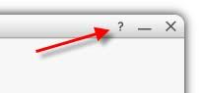
With the implementation of web based help, we have removed the PDF files of the user manuals. You can print a PDF directly from the website at any time.
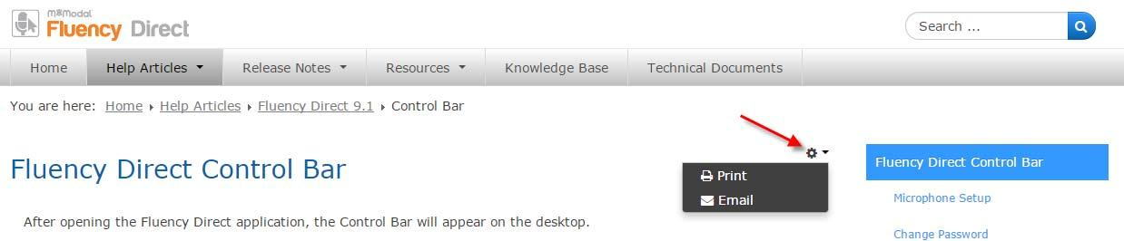

Mobile Microphone
The M*Modal Fluency Direct™ Mobile Microphone is a mobile application that allows clinicians to dictate using the M*Modal Fluency Direct desktop application without the need for a physical microphone attached to the PC. Once the mobile application is paired one time with a Fluency Direct login, the user can dictate using Fluency Direct running on any physical desktop or virtual device without a need for docking, Bluetooth or physical connections. The application uses secure data transmission to stream audio from the mobile device directly to Fluency Direct running elsewhere. Mobile Microphone is currently available in the iPhone App Store and will soon be available with Android devices. NOTE: Additional information about requirements and security can be found on the portal.

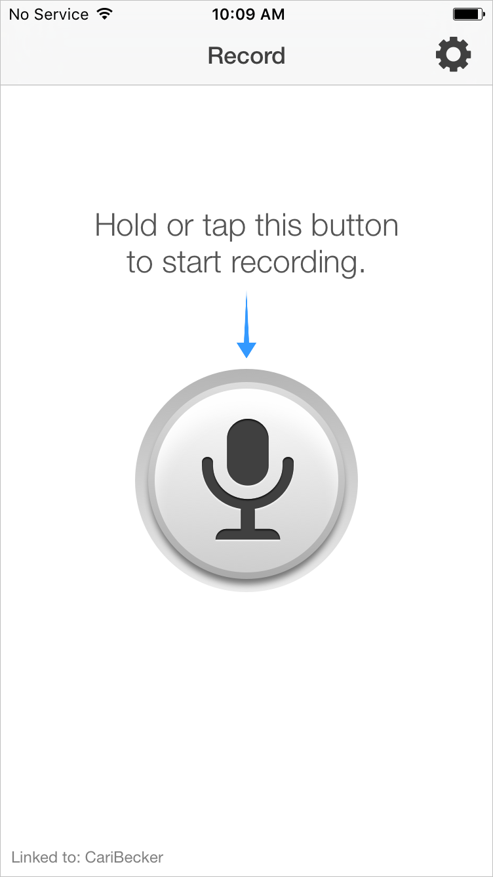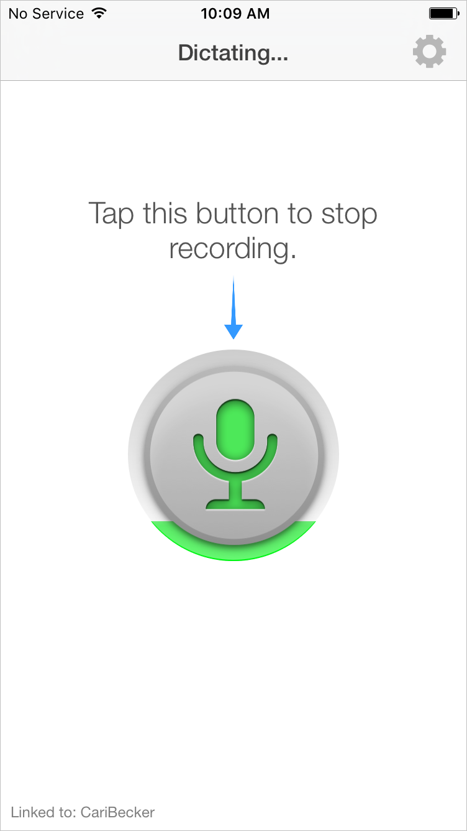

Unlinking Mobile Microphone
You can now unlink your mobile microphone from both the Fluency Direct Client and the Fluency Direct Mobile Microphone. You can access the "Unlink all mobile dictation devices..." option from the Microphone Setup dialog. Once unlinked, your phone and Fluency Direct User Account will no longer be tied together. You will need to link them again as necessary.

Correction Dialog
The Correction dialog now has formatting commands available. If the user is in an editor that supports formatting then these commands will be enabled as "blue" and a user can speak them while this dialog is displayed.

Visual Pronunciation and Pronunciation Options
In previous versions, one could store a new term via the Correction Dialog or Dictionary Add features and record a pronunciation. Because the pronunciations were not always optimally recorded and then stored “under the covers,” the term was not consistently recognized. We added new Visual Pronunciation feature and simpler Pronunciation Options (written, spoken, or recorded) to the Dictionary Add or Correction Dialog windows. Visual Pronunciation gives the user a reliable way of verifying dictionary entries to increase accuracy and speed. If the auto-generated pronunciation from the Written Form is not ideal, one can change the Spoken Form to match its true phonetics or record a pronunciation.

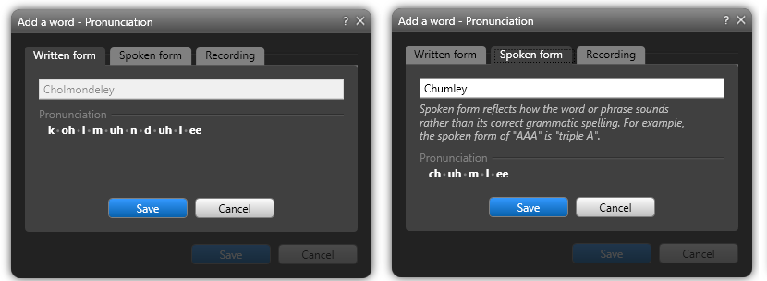

Recording a pronunciation is now easier. There are no extra buttons to click – simply use your designated record button on your handheld microphone or keyboard to capture the recording.

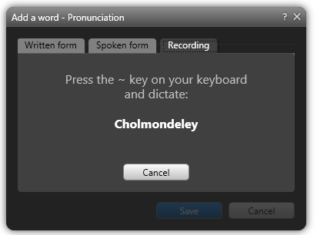
Spelling
We have added a new Spell Mode that will allow you to check and correct the spelling of a word from Speech Box, EHR’s, the Dictionary, or from the Correction dialog. To enable Spell Mode, you can use any of the following speech commands; Spell, Spell Mode, Spelling Mode, or Switch to Spell Mode.
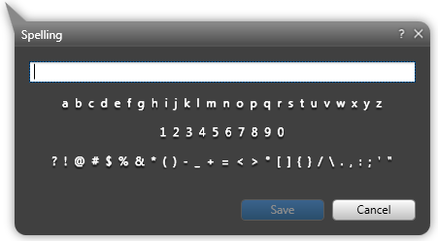

The Spell Mode dialog box will pop up and you can dictate or type in the correct spelling of the word. The Spell Mode works like the Correction Dialog but is limited to spelling only and does not present an option to save it to one’s dictionary. This may be useful when needing to dictate a proper noun that is used infrequently.

M*Modal Exchange
The M*Modal Exchange is now available for Fluency Direct 10.0 and higher. The Exchange allows you quickly personalize Fluency Direct by downloading predefined Command libraries (*.fdc), dictionary entries (*.fdd), abbreviations (*.fdb), button mappings (*.fdb) and datasets (*.fds). You can then import these into your system. In addition, users can export their existing personalizations and upload them to the Exchange to share with others.

Import/Export
The Fluency Direct Dictionary now has import\export capabilities. Users can export categories to a Fluency Direct native format (*.FDD) and import via Fluency Direct FDD, Dragon TXT, or CSV format.
You can:
- Export dictionary items into a Fluency Direct native FDD file format.
- Import commands via the Fluency Direct FDD file format.
- Import Dragon TXT format
- Import items via CSV format
- Access to a library of dictionary items hosted by M*Modal via the M*Modal Exchange.

CSV format:
Written Form, Spoken Form, (optional:Category)

Dragon TXT format:
@version=Plato-UTF8
Written Form\\Spoken Form

Dictionary
By Accessing the Manage Dictionary Dialog via Shift+Click users can now review pronunciations in bulk. New Context Menu items also exist to make it easier to re-categorize dictionary entries.

Pronunciation Review/ Hidden Words
The dictionary dialog can be launched via Shift+Click. When doing so, the dialog is displayed in advanced mode and allows the user to quickly see pronunciations as well as hidden words. Saved pronunciations can be reviewed quickly in this mode while hidden words can be modified. Hidden words are used to hide dictionary entries from users. For example, if you would like to exclude profanity from being recognized by the system, you can add profane words to the Excluded Category. By making those words hidden users are not subjected to seeing them when doing dictionary reviews.

Words can be marked hidden by setting the visibility on the Add/Edit dialog.

Term Suggestions
We have updated the Correction Dialog so that it now only suggests meaningful additions to the dictionary, which will avoid needless dictionary duplicates. Single, known words are not suggested as individual suggestions, but are suggested as part of total phrase regardless of capitalization. Unknown capitalized words are suggested individually, also as part of whole phrase. Multiple capitalized words are suggested as single suggestion. Capitalized word/words/Phrase/names are suggested always as single suggestion. Fluency Direct will not make suggestions more than 6 words long.

In the below example, two unknown terms were identified and recommended for the user to add to their dictionary in one, quick step.

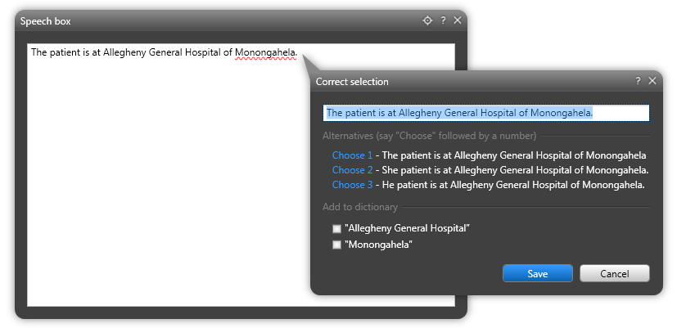

Abbreviations

Import/Export
Abbreviations now have import/export capabilities. Users can export categories to a Fluency Direct native format (*.FDA) and import via Fluency Direct FDA or CSV format.

You can:
- Export abbreviations into a Fluency Direct native FDA file format.
- Import commands via the Fluency Direct FDA file format.
- Import items via CSV format
- Access to a library of abbreviation items hosted by M*Modal via the M*Modal Exchange.

CSV format:
Original, Replacement

Hidden Mode
The abbreviation dialog can be launched via Shift+Click. When doing so, the dialog is displayed in advanced mode and allows the user to quickly see hidden abbreviations Saved abbreviations can be reviewed quickly in this mode while hidden abbreviations can be modified. Hidden abbreviations are used to hide entries from users. For example, if you would like to alter the format of certain output, but the end result doesn't truly fall under the category of abbreviation.

Commands
Fluency Direct now allows multiple custom commands with the same name with different availability. This allows for the creation of commands with the same name to run different actions based on context defined via Availability. For example, this could be used to have different behavior for “next field” in different EHRs. Previously command availability could only be defined at the group level. With the new approach, commands can inherit the availability defined by the group or deviate with its own availablity. This allows for a single group to better cover all portions of the EHR with a single command group.

Import/Export
Users now have the option to import and export Commands in Fluency Direct.

You now can:
- Export individual commands and command groups into a Fluency Direct native FDC file format.
- Import commands via the Fluency Direct fdc file format.
- Import Dragon Auto-Text via XML format
- Import Dragon Macros via XML format
- Import Dragon Advanced Scripting via XML format
- Access to a library of commands hosted by M*Modal via the M*Modal Exchange.

Availability
Updated Command Group Availability to include the following four (4) options:
- Available everywhere on the desktop regardless of application or window title
- Available only in windows with certain titles
- Available only in certain applications. Previously 9.1 did not include the Applications option.
- Also available on mobile. If a command includes a Text Step then that portion of a command can now be called from Mobile applications such as Fluency Mobile, Epic Haiku and other M*Modal Mobile SDK integrated applications.

Expanded Command Actions

Previously, there were only four actions one could execute within a group or personal voice command: Text, Key, Wait, and Script. Four additional actions have since been added: Mouse, Window, Command, and Comment. The Wait action has added functionality. Commands built with these new feature enhancements are not backwards compatible into older versions of Fluency Direct.
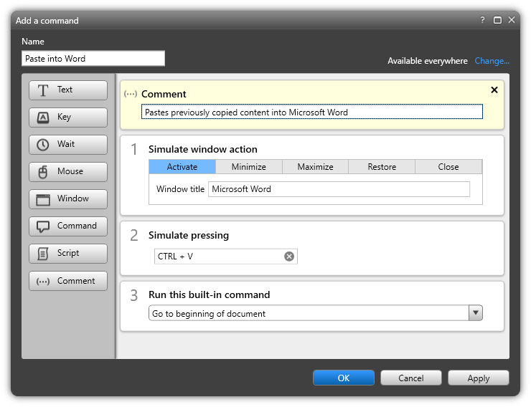

Mouse

We have enabled mouse clicks to be executed from the Custom Commands dialog. The Mouse action (Left click, Right click, Double click, or Move pointer) are available at any coordinates in the window. This position is based on the application window, NOT the screen so monitor sizes won’t affect it.

NOTE: When performing this command, you must be in the application that the command was created in. For example, if you register Mouse Clicks for creating a new document in Word, you must have Word open and active to use the command. Tip: Use the Window action to active the desired window prior to the Mouse action.

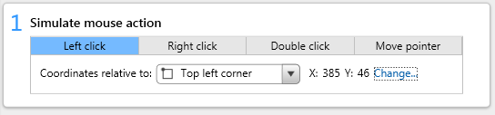

Commands

We have enabled built-in commands to be executed from the Custom Commands dialog. Built-in Commands are the pre-populated speech commands that M*Modal has built into Fluency Direct. You can use these voice commands as an action within a multi-step Command sequence to perform the function you need. When you add the Command action, you can start typing the voice command that you would normally speak (e.g. Select all) and select from the list that appears. The voice command will then be added to your Command steps. Tip: Cursor-moving commands can be used when inserting a block of text so that one can begin dictating in their intended place after the command is executed.

Window

We have enabled window actions to be executed from the Commands dialog. The Window action allows you to assign specific actions to an application window. The application (the one specified in the Window title) must be running in order for the actions to execute.

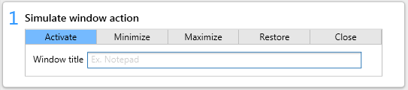

Activate - This command will bring the application window to the forefront and give it focus.
Minimize - This command will minimize the window so that it is no longer visible.
Maximize - This command will maximize the window so that it uses the entire screen space.
Restore - This command will restore an application to its original size from a minimized state.
Close - This command will close the application completely.

The action of activating a window can be a helpful initial step when creating mouse-click or keyboard shortcut commands – especially in multi-step commands where the window focus may be changing.

Wait
The Wait custom command step has been expanded to optionally include "Wait for Window" feature. This will allow users to wait for a window for a particular title bar to appear, for a given number of seconds or whichever comes first. If the dialog is launching using Shift+Click then a command can also be hidden from the Manage Command Dialog.

Comment
Users can now add Comment steps for better clarity. This “step”takes no action and does not impact the command performance or sequence.

Grammar IDE
You can now define commands using JSpeech Grammar Format (JSGF), The "Set Grammar" function is an advanced feature only available via Shift+Click launch of the command dialog. You can then use the set grammar to define JSGF syntax.

Example Grammar:
public <s> = test <count>;
<count> = ( 1 | 2 | 3 | 4 | 5 | 6 | 7 | 8 | 9 | 10 | 11 | 12 | 13 | 14 | 15 | 16 | 17 | 18 | 19 | 20 | 21
| 22 | 23 | 24 | alpha | bravo | charlie | delat | echo | foxtrot | golf | hotel | india | juliet | kilo
| lima | mike | november | oscar | papa | quebec | romeo | sierra | tango | uniform | victor | whiskey
| xray | yankee | zulu | a | b | c | d | e | f | g | h | i | j | k | l | M | n | o | p | q | r | s | t
| u | v | w | x | y | z );

Example Script Step JavaScript:
fd.InsertText("Dictated text = " + fd.Result() + "\n");
fd.InsertText("Count parameter = " + fd.Result.Parameter("count") + "\n");

Example Output:
Dictated text = test 1
Count parameter = one

Data Sets for Grammars
Data Sets can be defined as the variable portion of a grammar. Data Sets can be defined in the Data Set Dialog by a individual user or published by an Administrator. This is an advanced feature that can only be found by using Shift+Click to access the Personalization menu.

Example Grammar:
public <s> = order <medications> to be taken every <numbers> (hour | hours);

Example Script Step JavaScript:
fd.InsertText("Dictated text = " + fd.Result() + "\n");
fd.InsertText("Medication parameter = " + fd.Result.Parameter("medications") + "\n");
fd.InsertText("Number parameter = " + fd.Result.Parameter("numbers") + "\n");

Example Output:
Dictated text = order Tylenol to be taken every 6 hours
Medication Parameter = Tylenol
Number Parameter = 6

Data Sets – Import/Export
Data Sets have import/export capabilities. Users can export categories to a Fluency Direct native format (*.FDS) and import via Fluency Direct FDS or CSV format. A FDS format carries with it the list name and CSV file assumes that a Data Set list is created and you are importing new items into it.

CSV format:
Key, Value

Scripting IDE
The Script Step in a Custom Commands now has Syntax Highlighting as well as intellisense suggestions on FD extensions to VBScript and Javascript. Information on how to use scripting in FD can be found in Command Scripting.

Formatting
A new advanced option has been added to formatting to allow the system to auto-capitalize after the insertion of a period when dictated. This option is new and off by default. It will only work with Level 3 compatible text controls.

Explicit capitalization and numbers
Formatting options have been expanded

- Beginning of sentence options for numbers. You can choose either a numeric or spelled form
- Middle of sentence options for numbers. You can choose either a numeric or spelled form
- Updated the formatting rules to include Explicit, which requires you to say Cap Next prior to capitalization. This is useful; in Level 2 applications and allows the user to have complete control over capitalization. In this way, the system will not automatically capitalize words erroneously.

Medical Specialty
A user's Medical Specialty can now be configured based on focused window or application. This can be useful to optimize speech recognition accuracy. For example, “Clinical Administration” can now be used for email and Cardiology for a EKG reporting system for a single user. Assuming specialty mapping is defined correctly; the switching of specialty happens in the background and should not be detectable by the user.

Device Button Mapping

Starting in version 7.85, device button mapping was available, but locked down and site-wide distributed through the installation. We now have Device Buttons available from the Personalization menu and configurable by any user. The changes made follow the user, just like one’s commands. Device Buttons can be customized by administrators and published to different users via groups.

Device Buttons allows you to assign specific actions to buttons on your recording device or keyboard hotkeys. Actions can include recording modes, key presses, or voice commands – including built-in, group-level, or personally-made c
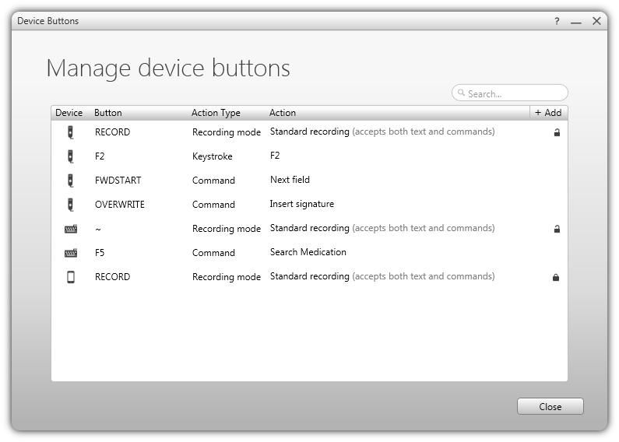

Mobile Microphone App
Added a "Combined" recording mode to device button mappings for the Mobile Record button. This will allow a user to have more control of mobile recording modes from the Fluency Direct client. Combined mode can act both as push to talk and toggle to talk. If the user hits the button quickly once, Toggle mode is used. If the user holds the button the push mode is assumed. Previously this can only be set from the mobile device. This will not be able to truly set the mobile app until a new version of the mobile microphone apps is released. We anticipate these mobile app updates to be available early Q2 2017.

Nuance Power Mic I and Power Mic II
The Nuance Power Mic I and Power Mic II are now supported by Fluency Direct for both Audio and Button Presses. This will only work with Fluency Direct installed on a local workstation. Buttons can be configured via Device Button Mappings.

Better Microphone, Foot Pedal and Hand Control Support
Olympus and Philips foot pedals and hand controls are supported and can be configured via Device Button Mappings.

Olympus Microphones no longer require the install of specialized drivers with the Fluency Direct Client (OlympusDirectrecRedist.msi is no longer required to be run). All needed functionality is built directly into the Fluency Direct Client. This means the Fluency Direct client only needs to be installed in virtualized environments. You no longer need to worry about specialized drivers.
Fluency Direct allows you to set up device button actions for your Olympus RS31 and RS32 Footpedal and Hand Controller in the same way that you define the button actions for you microphone.

Once you have installed your foot pedal or hand controller, click the Add New Action button. The Add a device button action window will appear. From here, click in the device button field and then select your footpedal (right, top, left) or hand controller (right, center, left). You'll notice that the device button field will display a hand or foot depending on the controller set.

Recording Mode
When adding a new device button, you can select the type of recording mode: Standard Recording, Text Only Recording, or Command Only Recording. This allows for finer control of recording behavior and allows users to assigned different behavior for different microphone types. In this way headsets, foot pedals and hand controls can use Toggle to Talk where a handheld microphone can use Hold to Talk.

Import/Export
Device Buttons now have import/export capabilities. Users can export categories to a Fluency Direct native format (*.FDB) and import via Fluency Direct FDB format.

Speech Box

We have made improvements to the behavior of the floating Speech Box, including the ability to set the dictation target using the Set Dictation Target voice command or target button in the corner of the window.

We have added improved functionality and transition along with notifications, when necessary so dictated text is not accidentally lost.

A transparency adjustment feature has also been added to allow for a translucent overlay, not hiding important information beneath it.

Account Settings for Self Service Password Resets
When performing your initial user setup, you will be asked to set up your Account Settings which include a security question and answer, your email, and your password. This can be accessed independently from a Control Bar menu. For users migrating from <10.0 to 10.0 you will also be challenged to enter similar information on first use of the new Client.

The Manage Account Settings window allows you to manage important information in regards to your account. Existing users upgrading to 10.0 will be automatically prompted to fill this out.
This functionality can be disabled by setting <config key="EnableSelfServicePasswordReset" value="False"/>

Password Self Reset
By utilizing the Account Settings, users can have the option (defined by administrators) to click a Forgot Username or Password link. They will answer their security question and be emailed instructions for resetting their password. This functionality can be disabled by setting <config key="EnableSelfServicePasswordReset" value="False"/>

Troubleshooting

System Check
The Fluency Direct System check has been expanded perform a quick diagnostic, checks configuration and network resources of an FD installation to provide you with information about the Versions, Microphone, Authentication, and Workstation. You can click on file paths for logs and other files to quickly gain access to the folder storing the desired content.

Microphone Testing tools
TestOlympusDirectRecMike.exe and TestPhilipsSpeechMike.exe are now included with the application in the C:\ProgramData\MModal\DesktopDictationClient\Versions directories. These programs can be used to test handheld microphone functionality independent of Fluency Direct. This is useful to test microphone redirection in virtual environments or to assure the OS has the needed drivers installed.

Activity Log
The Activity Log is essentially a debug window for commands. It is a hidden feature and can be accessed by using Shift+Click to access the Help Menu. Once running, it displays information about command and script execution. In a script step you can use fd.DebugOutput to write meaningful debugging information to the Activity Log.

Published Items
For many published items such as Dictionary Items, Device Button mappings, and Data Set Items it is possible to modify them to a certain degree, For example, you can give your own pronunciation to a dictionary item. In some cases, you might want to revert that modification to the previous state published state. You can now do this via the “revert” context menu item available via right click.

CAPD

General Fixes in CAPD version > 7.11.11
- CAPD is no longer a separate MSI. CAPD is now incorporated into FD Installer
- Fix for issues related to use of single sign on - SSO user no longer has to be configured for CAPD as was required with previous versions. All message configuration will be based on the physicians' AuthorOID (not SSO AuthorOID)
- Reporting fixes and enhancements
- Full detail on included fixes are available here, Release Notes - CAPD

Actionable Messages
CDI Engage messages can now include actions, where user can update their document with the click of a button.

- Some messages require a simple replace to address the message while others present the user with options to choose from.
- Actions and correction options are configurable per customer.
- Actionable CdiEngage CHF 20170131

Support for HCCs
New message cards available for use with HCC applications, which displays relevant ICD-10 and HCC codes for documented conditions.

Release Notes
The Fluency Direct documentation site contains release notes for each version, including patches with details specific to issues. Please review the release notes for more information.

Version 10.0+

Version 9.1+

Version 8.0+

Version 7.85+

CAPD

